# CONSOLIDATED EXAM QUESTIONS INTERMOLECULAR FORCES AND GASES

Contents

CONSOLIDATED EXAM QUESTIONS INTERMOLECULAR FORCES AND GASES 1

Syllabus 2

SHAPES OF MOLECULES (VSEPR LEWIS/DOT DIAGRAMS/POLAR AND NON POLAR COVALENT) – 12.1, 12.2 3

2017 S1 3

2017 S2 3

2020 S1 3

2020 S2 3

2023 S1 6

2023 S2 7

INTERMOLECULAR FORCES – 12.3 9

2017 S1 2017 S2 9

2020 S2 12

2023 S1 2023 S2 14

CHROMATOGRAPHY – 13.1-13.2 17

2017 S1 17

2017 S2 17

2020 S1 2020 S2 18

2023 S1 2023 S2 21

PROPERTIES OF GASES AND KINETIC THEORY – 14.1-14.2 25

2017 S1 25

2017 S2 25

2020 S1 26

2020 S2 26

2023 S1 26

2023 S2 26

CALCULATIONS INVOLVING GASES – 14.3 27

2017 S1 27

2017 S2 27

2020 S1 30

2020 S2 30

2023 S1 34

2023 S2 34

# Syllabus

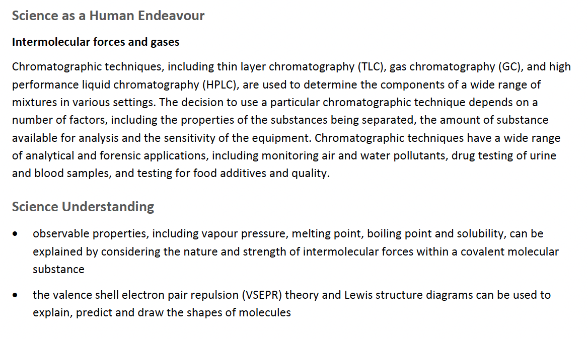

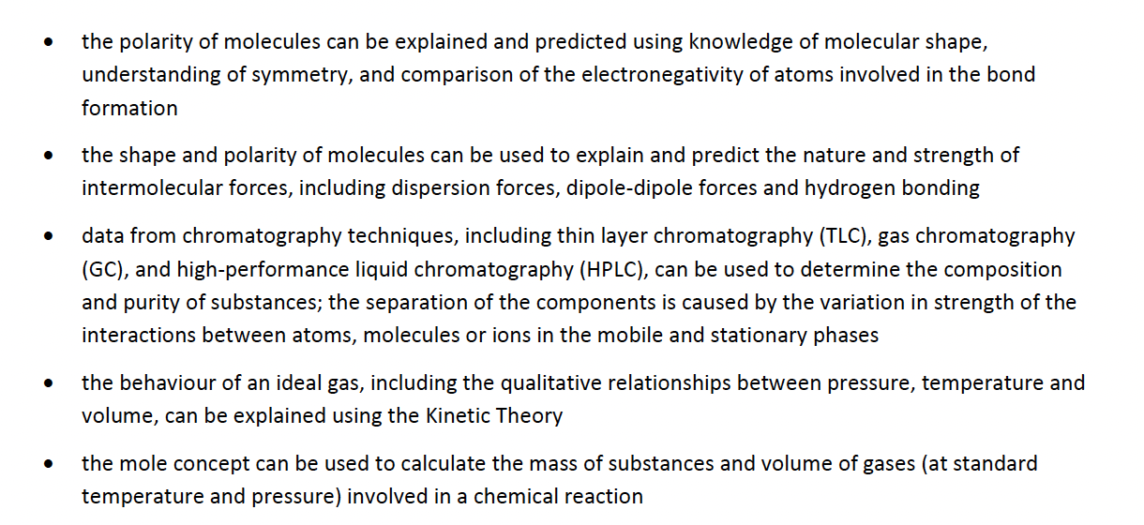

# SHAPES OF MOLECULES (VSEPR LEWIS/DOT DIAGRAMS/POLAR AND NON POLAR COVALENT) – 12.1, 12.2

## 2017 S1

## 2017 S2

## 2020 S1

## 2020 S2

## 2023 S1

## 2023 S2

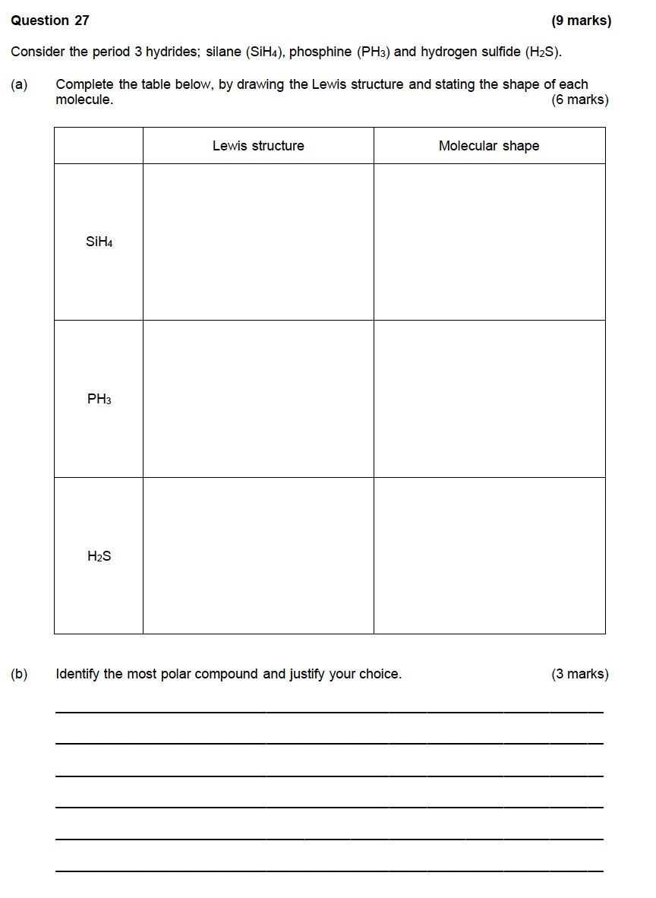

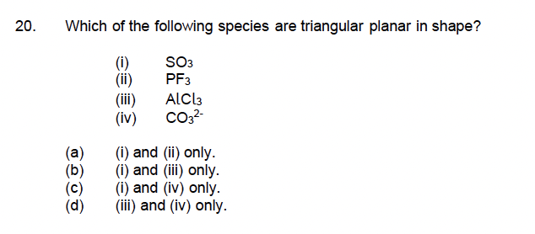

# INTERMOLECULAR FORCES – 12.3

# **2017 S1 2017 S2**

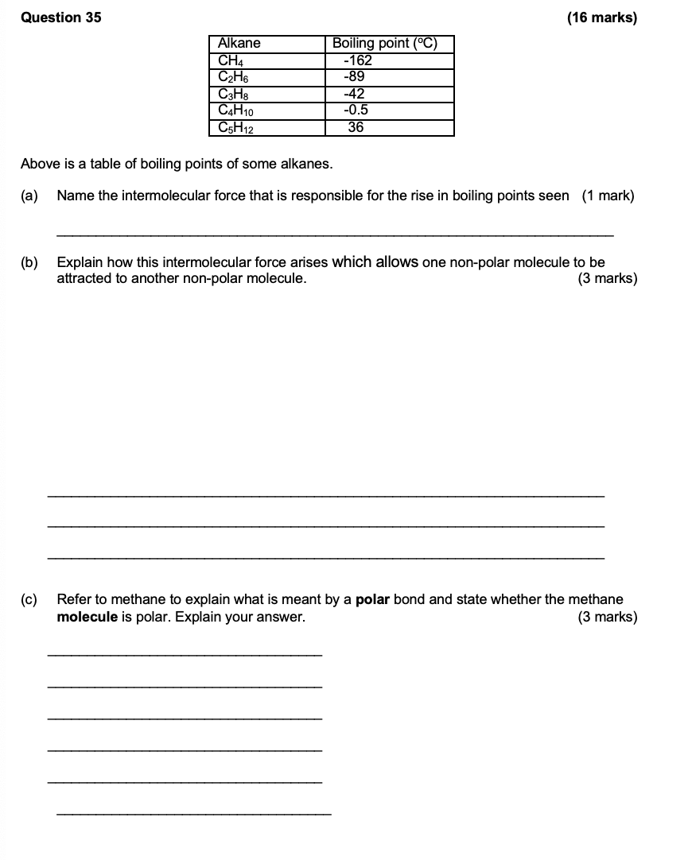

**2020 S1**

## 2020 S2

## 2023 S1 2023 S2

# CHROMATOGRAPHY – 13.1-13.2

## 2017 S1

## 2017 S2

## 2020 S1 2020 S2

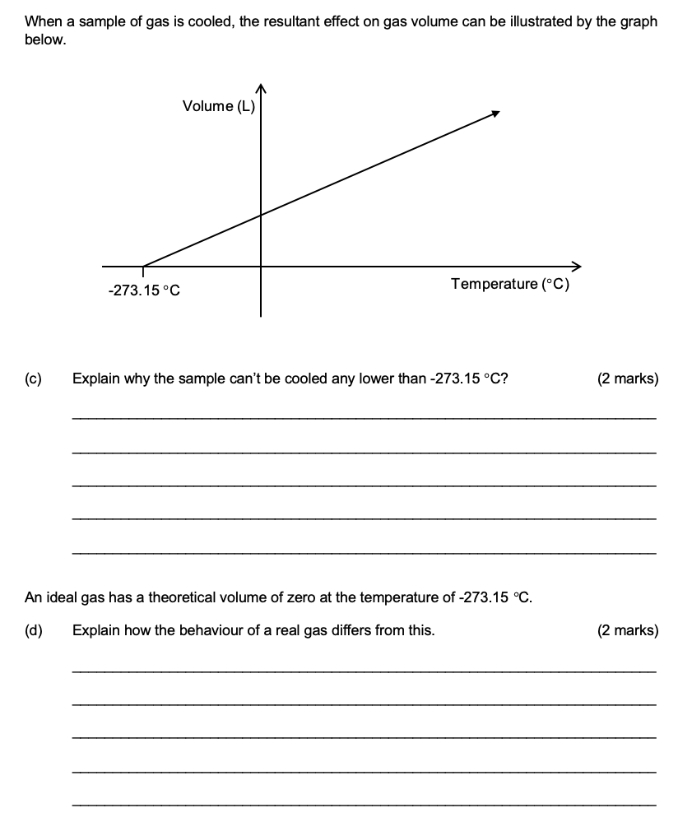

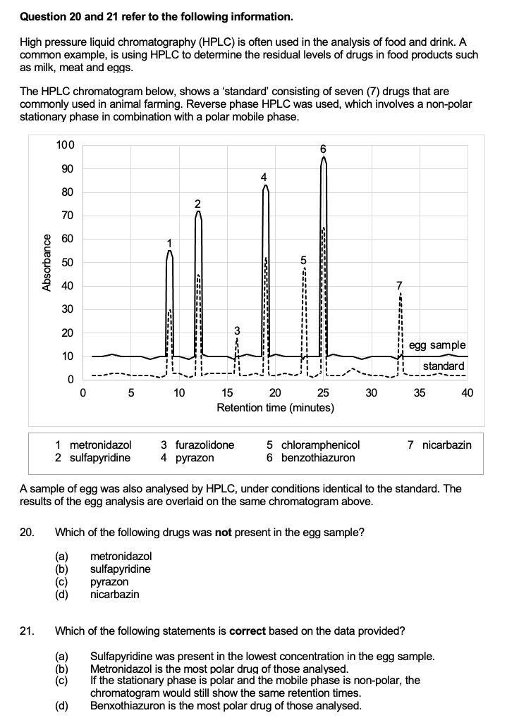

## 2023 S1 2023 S2

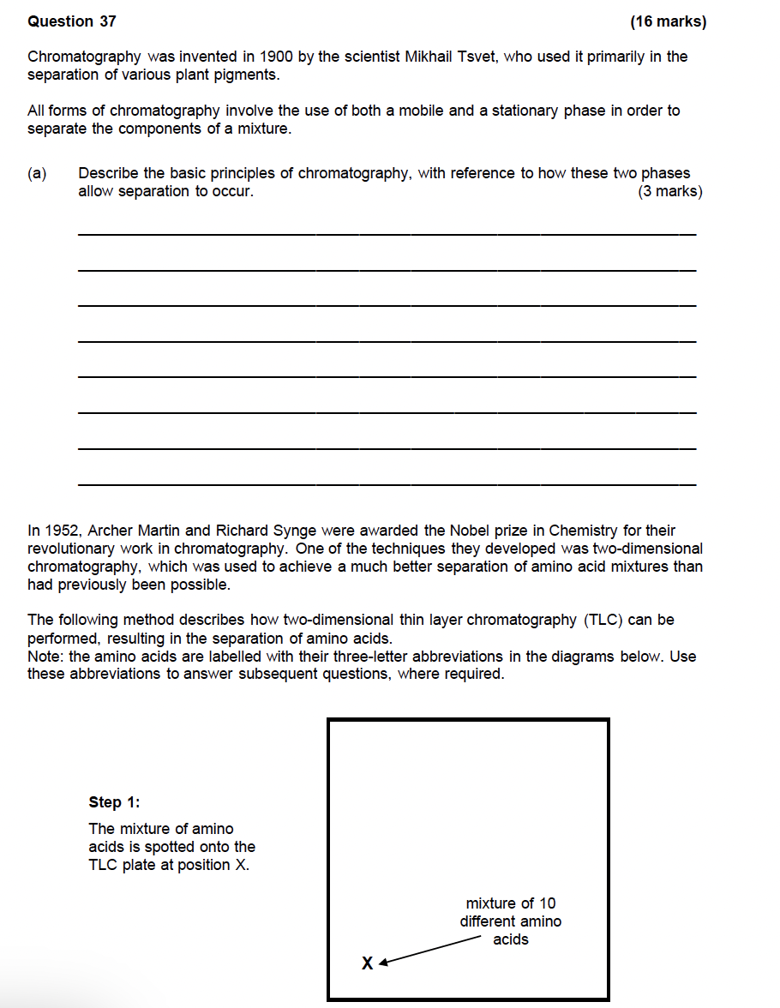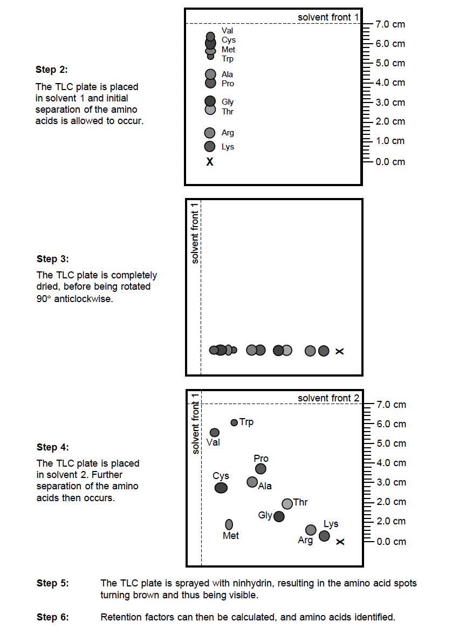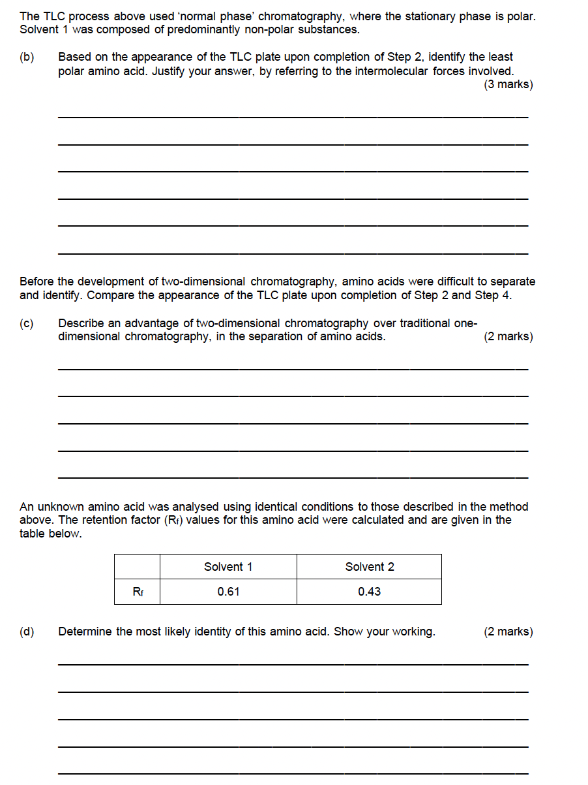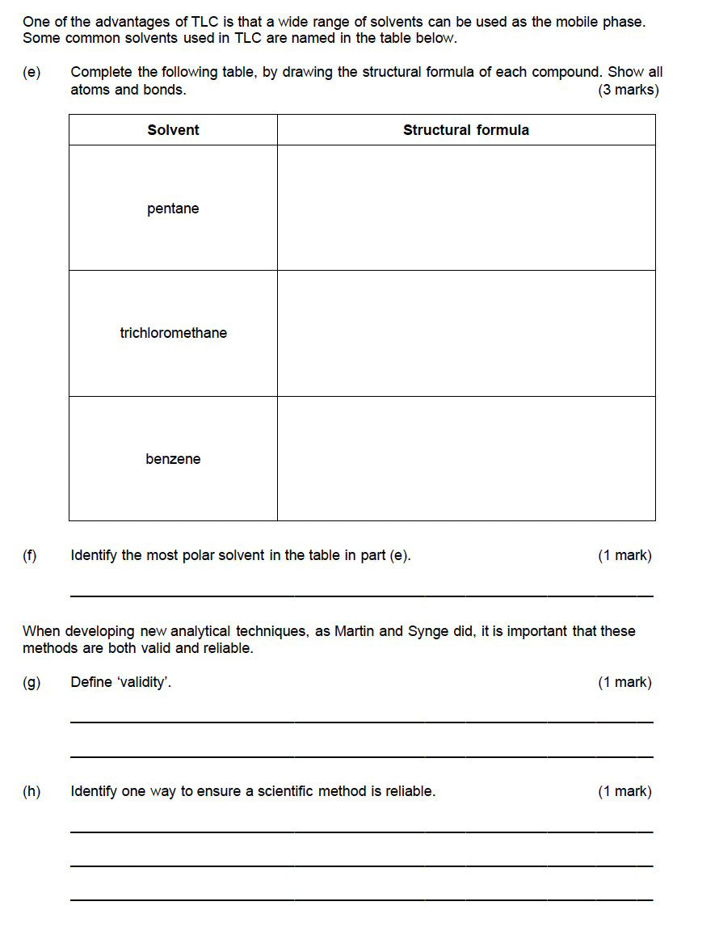

# PROPERTIES OF GASES AND KINETIC THEORY – 14.1-14.2

## 2017 S1

## 2017 S2

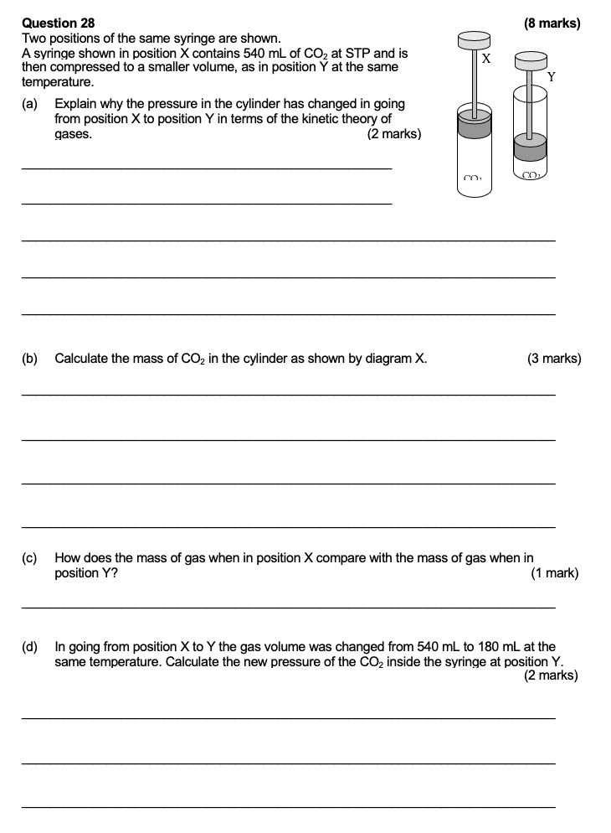

## 2020 S1

## 2020 S2

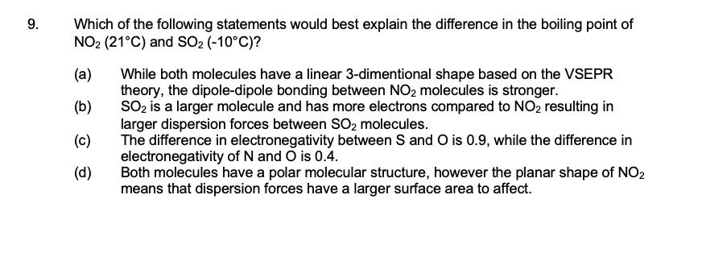

## 2023 S1

## 2023 S2

# CALCULATIONS INVOLVING GASES – 14.3

## 2017 S1

## 2017 S2

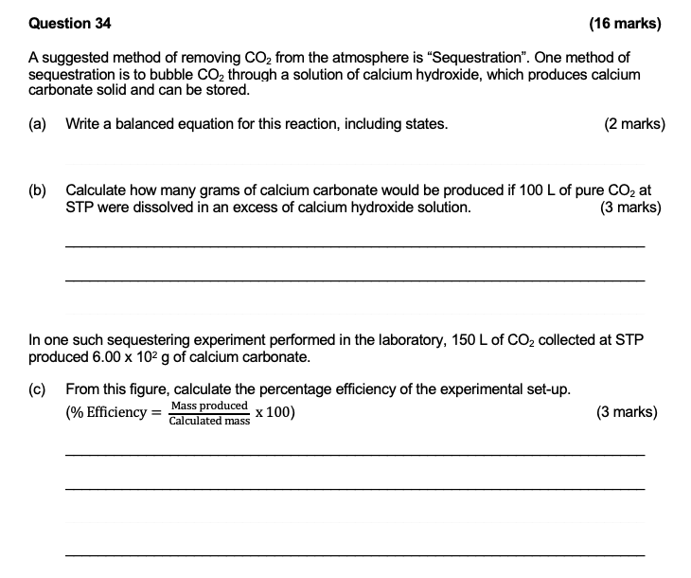

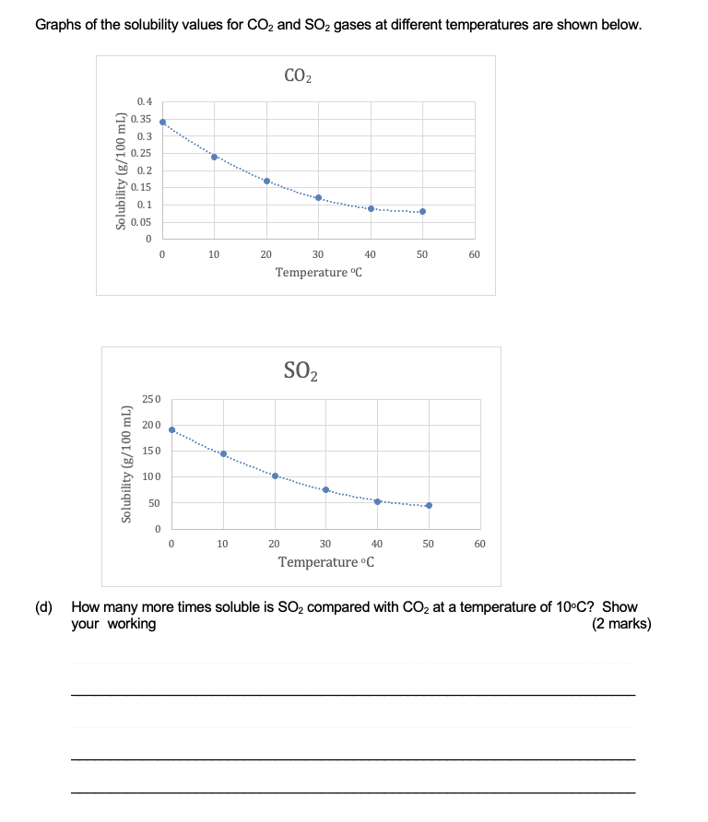

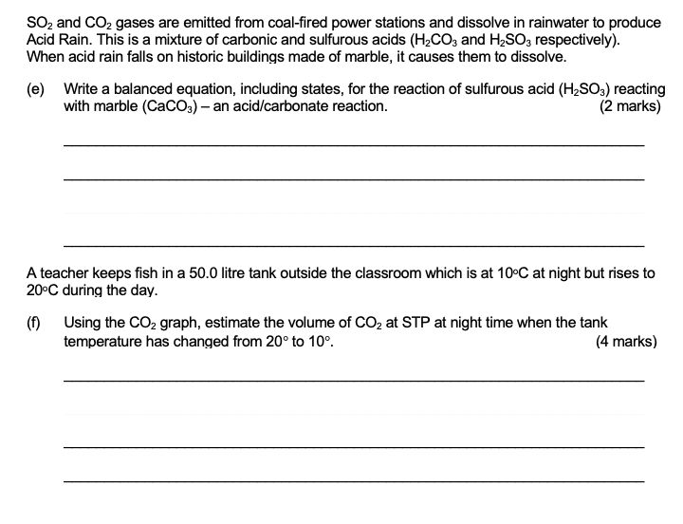

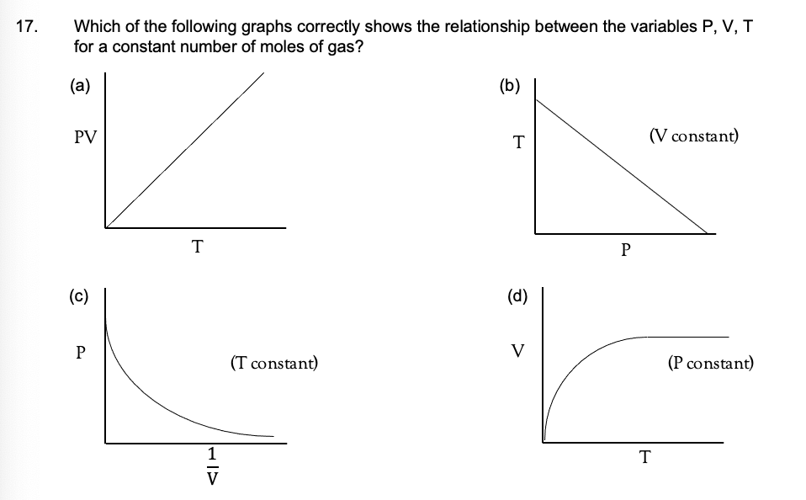

## 2020 S1

## 2020 S2

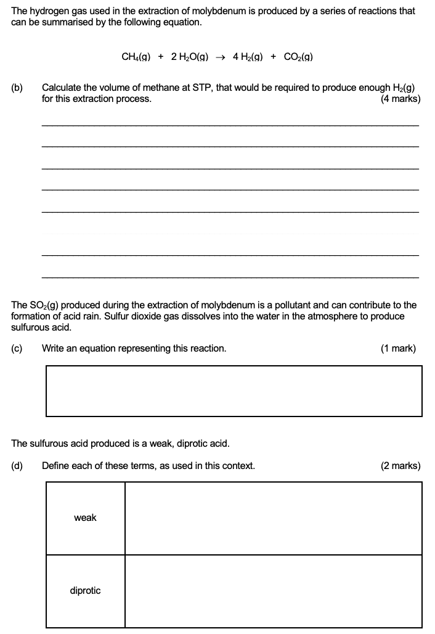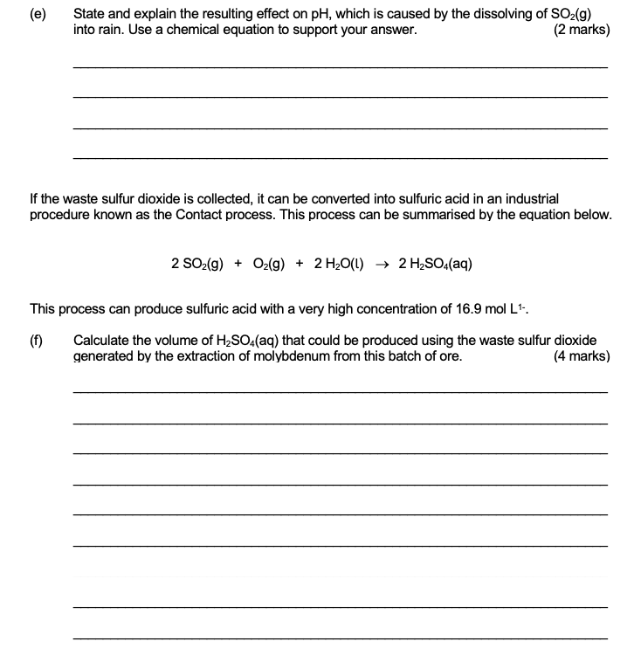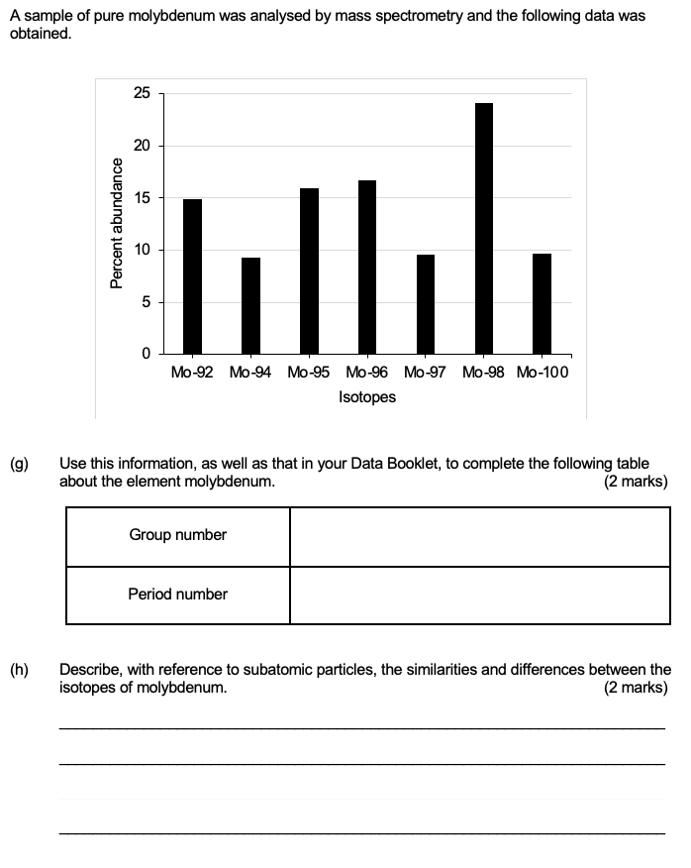

## 2023 S1

## 2023 S2